Tasks1
- Create a list of differences: on-premise infra vs cloud.

 | On-Premises | Cloud
Infrastructure Ownership | Fully owned and maintained by the organization | Owned and managed by a third-party provider
Initial Costs | High capital expenditure (CapEx) for servers, networking, and storage | Lower upfront costs; operational expense (OpEx), pay-as-you-go model
Scalability | Limited by available physical resources | Virtually limitless, scales on demand
Security & Compliance | Full control, easier to customize to specific compliance needs | Security measures rely on provider; shared responsibility model
Performance & Reliability | Lower latency for local operations, depends on internal setup | High uptime SLAs, may introduce latency depending on internet
Maintenance & Support | Internal IT team responsible for all updates | Provider handles maintenance, patches, upgrades
Flexibility | Custom-tailored, but scaling is slower | Rapid deployment, instant scalability
Deployment  Time | Weeks to months (hardware delivery, setup) | Minutes to hours (via web console or APIs)
Customization | High level of customization possible | Customization limited to available services/features
Disaster Recovery | Requires in-house DR planning and backup solutions | Built-in DR options (e.g., snapshots, multi-region)
Accessibility | Local network or VPN needed | Accessible over the internet from anywhere
Upgrades | Manual software/hardware upgrades | Auto or managed upgrades
Resource Utilization | Often underutilized hardware | Right-sized resources (auto-scale, elastic)
Compliance & Auditing | Full internal control over data and logs | Cloud providers offer compliance tools, but control is shared

- AWS available services list.

1. Compute
Service | Use
Amazon EC2 | Run scalable virtual machines in the cloud
AWS Lambda | Run code without managing servers (serverless)
Amazon ECS | Run and manage Docker containers
Amazon EKS | Managed Kubernetes for container orchestration
Elastic Beanstalk | Deploy and scale web apps quickly
AWS Batch | Run batch computing workloads on demand

2. Storage
Service | Use
Amazon S3 | Store and retrieve any amount of object data
Amazon EBS | Attach block storage volumes to EC2 instances
Amazon EFS | Scalable network file system for EC2 instances
Amazon FSx | Managed file systems for Windows or Lustre

3. Networking & Content Delivery
Service | Use
Amazon VPC | Isolated virtual network for AWS resources
Route 53 | Scalable domain name system (DNS) service
CloudFront | Deliver content globally with low latency
Elastic Load Balancing (ELB) | Distribute traffic across multiple targets

4. Database
Service | Use
Amazon RDS | Managed relational database (MySQL, PostgreSQL, etc.)
Amazon DynamoDB | NoSQL database with high performance and scalability
Amazon Aurora | High-performance relational database engine
Amazon Redshift | Data warehousing and analytics at scale
Amazon ElastiCache | In-memory cache for speeding up databases

5. Identity, Access & Security
Service | Use
AWS IAM | Manage users, groups, and permissions securely
AWS KMS | Encrypt and manage cryptographic keys
AWS Shield | Protect applications from DDoS attacks
AWS WAF | Filter web traffic using custom rules
Secrets Manager | Securely store and access sensitive credentials

6. Management & Monitoring
Service | Use
CloudWatch | Monitor logs, metrics, and set alarms
CloudTrail | Track user activity and API calls
AWS Config | Track resource configurations over time
Systems Manager | Automate and manage server configurations

7. Developer Tools
Service | Use
CodeCommit | Private Git repositories for source control
CodeBuild | Build and test code automatically
CodeDeploy | Automate code deployments to EC2 or Lambda
CodePipeline | Automate CI/CD workflows for applications

8. Machine Learning & AI
Service | Use
SageMaker | Build, train, and deploy ML models at scale
Rekognition | Analyze images and videos for objects and faces
Comprehend | Natural Language Processing (NLP) for text data
Polly | Convert text to natural-sounding speech
Lex | Build conversational chatbots using voice/text

9. Analytics
Service | Use
Athena | Run SQL queries on S3 data without a database
Kinesis | Real-time data stream processing
QuickSight | Create interactive BI dashboards and reports
AWS Glue | ETL service to prepare and move data for analytics

10. Migration & Transfer
Service | Use
Migration Hub | Track application and server migrations
DMS (Database Migration Service) | Migrate databases to AWS easily
Snowball | Transfer large datasets physically to/from AWS
Transfer Family | Secure file transfers (SFTP, FTPS, FTP) to S3

- Launch a simple Ubuntu VM on AWS Free Tier.

- Created an EC2 instance for Ubuntu with name Ubuntu-VM-test
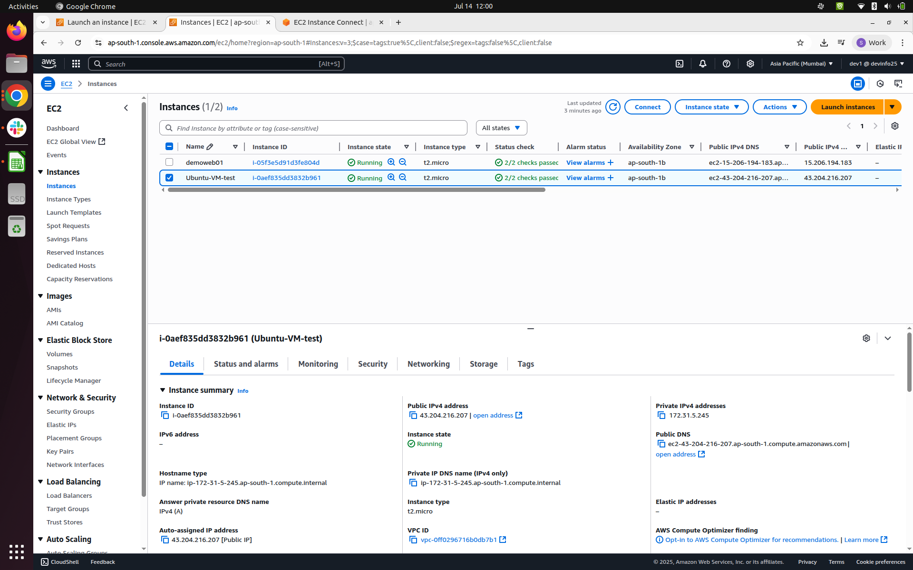

- Connected using a Public IP

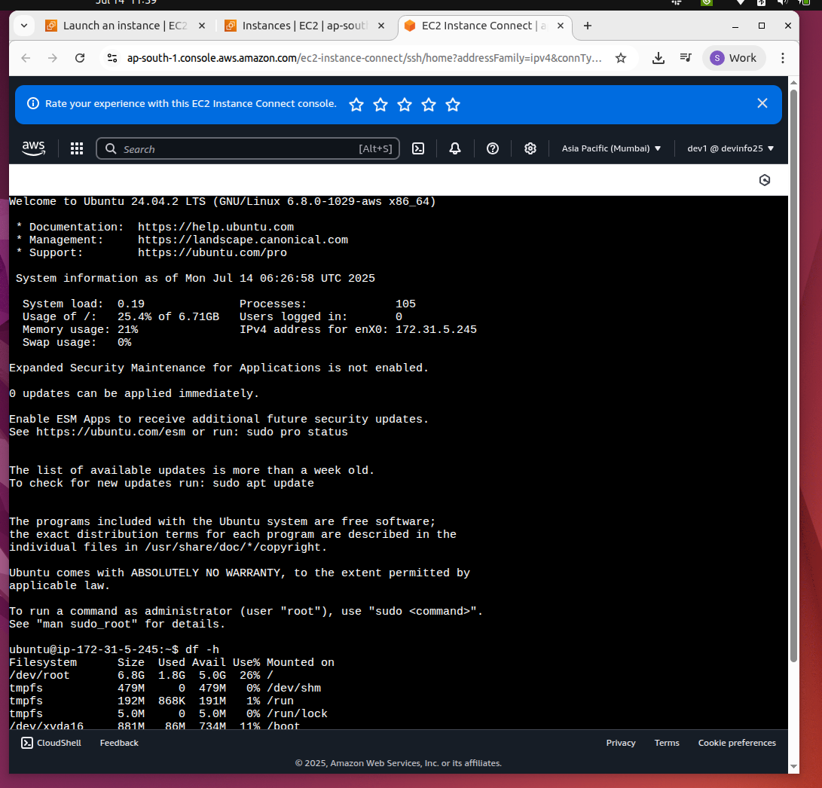
- Connected using a SSH client
